Homework – SQL Injection
Lab Goals: This lab aims to provide students with a basic understanding of exploiting several SQL injection attacks using the PortSwigger Academy and Burp Suite Community.
Submission: There is no submission.
Rubric: It is a non-graded activity.

Task 1: Create an account and prepare the environment.
Goal: Create an account in the PortSwigger Academy, which is required to access and execute the rest of the lab.
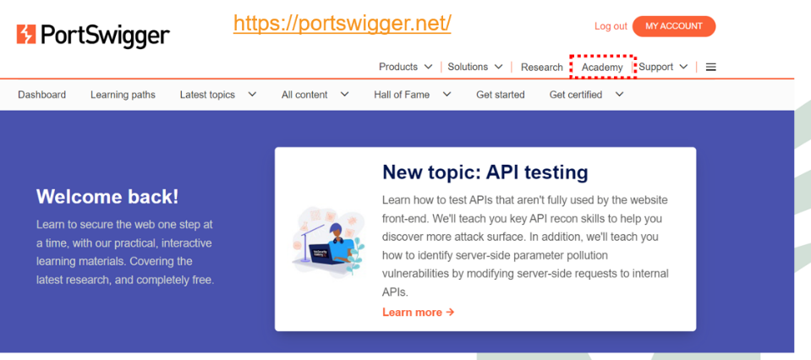
- Create an account and log in to the Academy.

- Scroll down and click on the link “View all topics”.
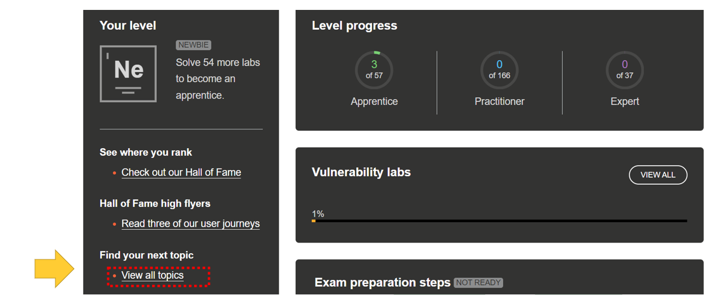

- Download and install the Burp Suite Community Edition: https://portswigger.net/burp/communitydownload.

- In the PortSwigger Academy, take this course: https://portswigger.net/burp/documentation/desktop/getting-started

Task 2 - SQL injection vulnerability in the WHERE clause, allowing retrieval of hidden data.
Goal: The goal of the exercise, which is a lab on SQL injection, is to perform a SQL injection attack that causes the application to display one or more unreleased products. This is achieved by exploiting a SQL injection vulnerability in the product category filter.
This lab contains a SQL injection vulnerability in the product category filter. When the user selects a category, the application carries out a SQL query like the following:
SELECT * FROM products WHERE category = 'Gifts' AND released = 1
To solve the lab, perform a SQL injection attack that causes the application to display one or more unreleased products.
After you are logged in to PortSwigger Academy, start the Burp Suite and complete these tasks.
- In the Proxy tab, open this webpage using the embedded browser:
  - https://portswigger.net/web-security/sql-injection/lab-retrieve-hidden-data
  - On the page, click on the bottom to access the Lab to open the Exercise.
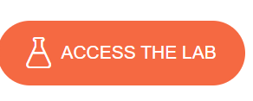
- Activate the interception in the Proxy Tab.

- Next, select one type of item in the menu (do not select All).

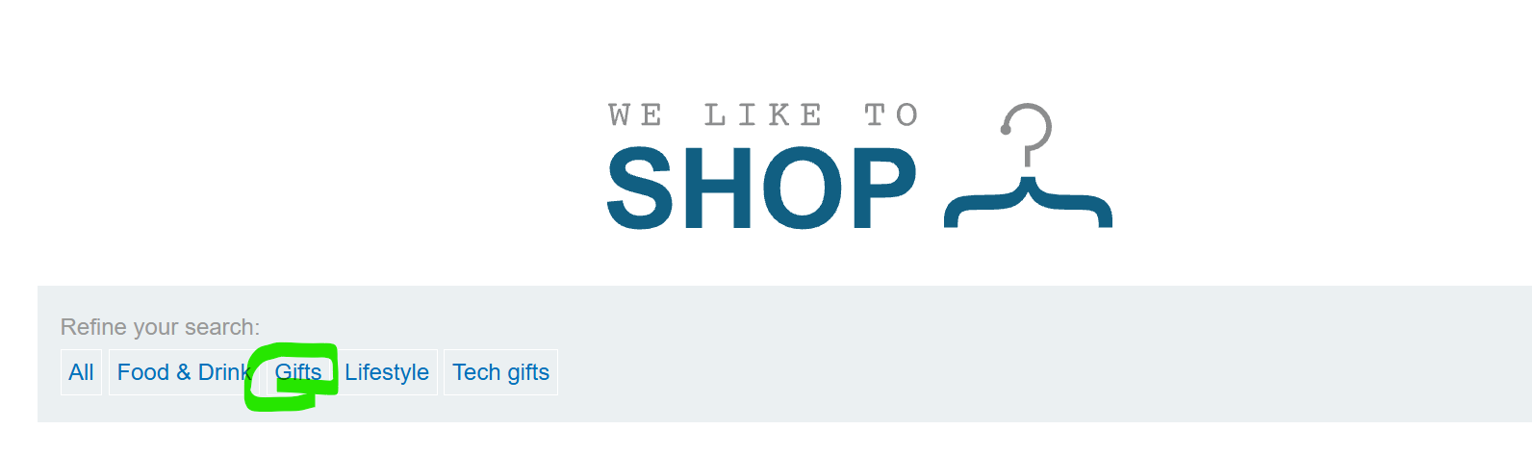
- In the Proxy, you can see the GET URI request.
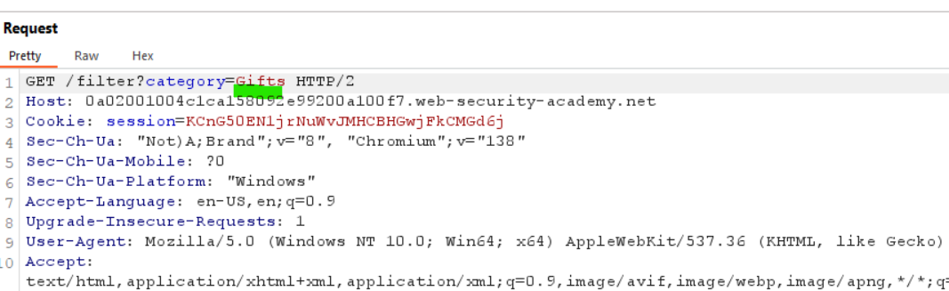
- We will attempt a simple SQL Injection to retrieve all the information stored in the database. To perform this task, we will use this string: ‘ OR 1=1--. This string is commonly used in SQL injection attacks, particularly in web applications where user input is directly incorporated into SQL queries without proper sanitization. Let's break down what each part means:
- ' (Single Quote): This is often the most critical part. In many SQL queries, strings are enclosed in single quotes. If a user's input is expected to be a string (e.g., a username or product category), an attacker can use this quote to "break out" of the intended string literal. For example, if a query looks like SELECT * FROM products WHERE category = 'YOUR_INPUT_HERE', providing ' as input would make the query look like SELECT * FROM products WHERE category = ''. This effectively ends the string prematurely.
- OR: This is a standard SQL logical operator. It combines two conditions, returning true if at least one of the conditions is true.
- 1=1: This is a condition that is always true. It's a common trick in SQL injection because when combined with OR, it makes the entire WHERE clause true, regardless of what the original condition was.
- -- (Double Hyphen): In SQL, -- (two hyphens followed by a space) is the standard way to denote the start of a single-line comment. Anything after -- on the same line will be ignored by the database. The space after the hyphens is essential for it to be recognized as a comment in most SQL dialects.
- To perform this attack, in the Proxy Tab, replace the URL for ‘+OR+1=1-- and click on forward. Remember to replace the space with + to code the parameter correctly.

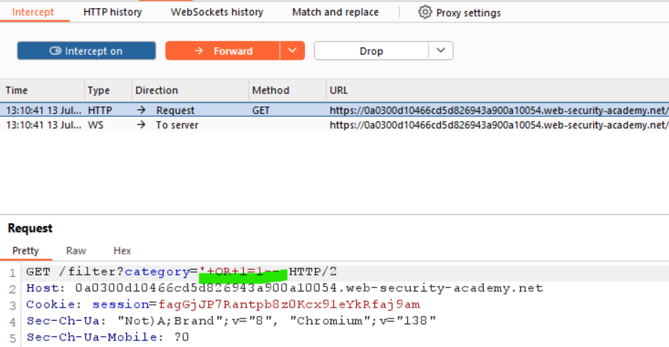

- You see that all the results will be returned, and you will receive a message of success.

Task 3 - SQL injection vulnerability allowing login bypass.
Goal: The goal of this lab is to solve a SQL injection vulnerability in the login function by performing a SQL injection attack that logs into the application as the administrator user.
This lab contains a SQL injection vulnerability in the login function. To solve the lab, perform a SQL injection attack that logs in to the application as the administrator user.
After you are logged in to PortSwigger Academy, start the Burp Suite and complete these tasks.
- In the Proxy tab, open this webpage using the embedded browser:
  - https://portswigger.net/web-security/sql-injection/lab-login-bypass
  - On the page, click on the bottom to access the Lab to open the Exercise.

.

- Click on the My Account link.

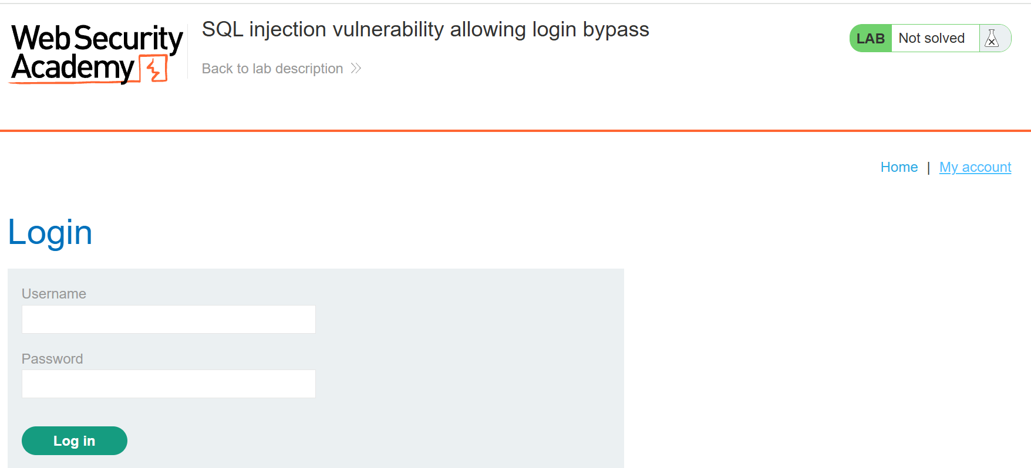

- Activate the interception in the Proxy Tab.

- In the login page, set username = administrator and any random string for password (e.g., 123456), and press Log In.

- In the Proxy Tab, select the POST request message, and in the Inspector/Request Body Parameter, replace the content of the username for administrator--. Click on the forward all button. This command makes the system ignore anything after the administrator string, disabling the check for the password.

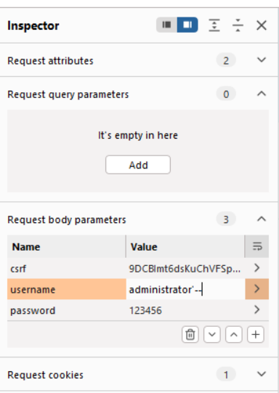
- You have access to the My Account page with Administrator rights.
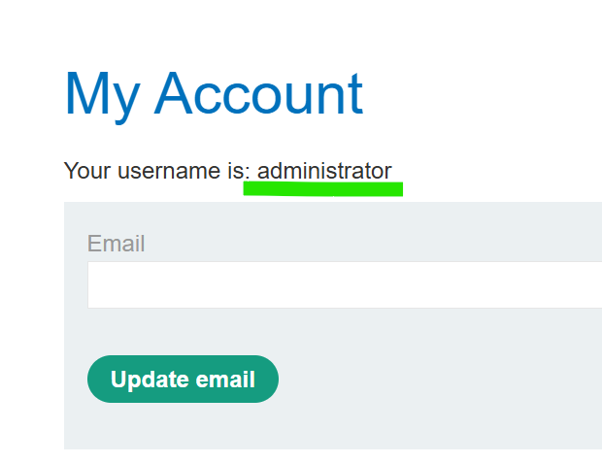
Task 4 - Blind OS command injection with output redirection.
Goal: The goal of this lab is to execute the whoami command and retrieve its output. This is achieved by exploiting a blind OS command injection vulnerability in the feedback function. The command's output is redirected to a file in a writable folder (/var/www/images/), and then the contents of that file are retrieved using the image loading URL.
The whoami command is a standard command-line utility found on most Unix-like operating systems (Linux, macOS, etc.) and also on Microsoft Windows operating systems (since Windows Server 2003). Its primary purpose is to print the effective username of the current user.
This lab contains a blind OS command injection vulnerability in the feedback function.
The application executes a shell command containing the user-supplied details. The output from the command is not returned in the response. However, you can use output redirection to capture the output from the command. There is a writable folder at:
/var/www/images/
The application serves the images for the product catalog from this location. You can redirect the output from the injected command to a file in this folder, and then use the image loading URL to retrieve the contents of the file. To solve the lab, execute the whoami command and retrieve the output.
After you are logged in to PortSwigger Academy, start the Burp Suite and complete these tasks.
- In the Proxy tab, open this webpage using the embedded browser:
  - https://portswigger.net/web-security/os-command-injection/lab-blind-output-redirection
  - On the page, click on the bottom to access the Lab to open the Exercise.


- Click on the submit feedback. When the returned page is opened, start the intercept in the Proxy Tab.

- Fill in all the fields in the form. Click on the Submit feedback button.
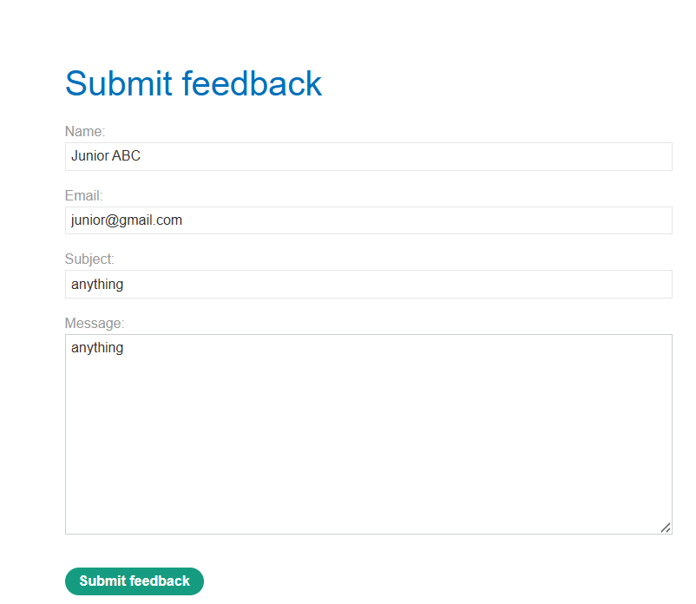
- Select the POST request and change the e-mail for this string:
email=||whoami>/var/www/images/output.txt||
- This line, email=||whoami>/var/www/images/output.txt||, is a classic example of an attempt to perform an OS command injection attack, specifically using a technique where the output of a command is redirected to a file.

- To understand the injection, it is required to understand what the || command means. In many shell environments (like Bash on Linux/Unix), the || (double pipe) operator is used for conditional execution or command chaining. It means "execute the command on the right only if the command on the left fails (returns a non-zero exit status)."

- Assuming the injection is successful and the || allows command chaining:
  - The whoami command will be executed on the server.

  - The output of whoami (e.g., www-data or apache) will not be displayed directly to the attacker (which is why it's a "blind" injection).

  - Instead, that output will be written into a file named output.txt located in the /var/www/images/ directory.
    - /var/www/ is a standard directory for web server content.
    - /var/www/images/ is often a public-facing directory where image files are stored, and importantly, it's typically writable by the web server process and accessible via HTTP (e.g., http://example.com/images/output.txt).

- After understanding the meaning of the command, we will implement this injection in our lab server. In the Proxy tab, select the Inspector/Request Parameter Body, and replace the value of e-mail for the string: email=||whoami>/var/www/images/output.txt||

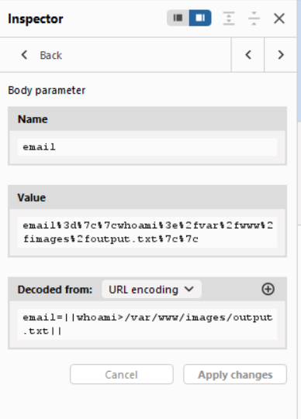
- Click on the Forward All button. If the injections work, you will receive a 200 OK, and the system will provide a successful message.
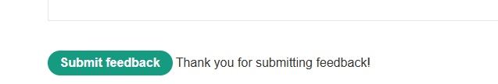

- Disable the interceptor and click on the home link to go back to the home page.

- On the page, select any item and click on the View details button. When the page opens, start the interceptor and refresh the page.

- In the Proxy Tab, press the Forward button until you have the GET Request message that returns the image file related to the selected item.
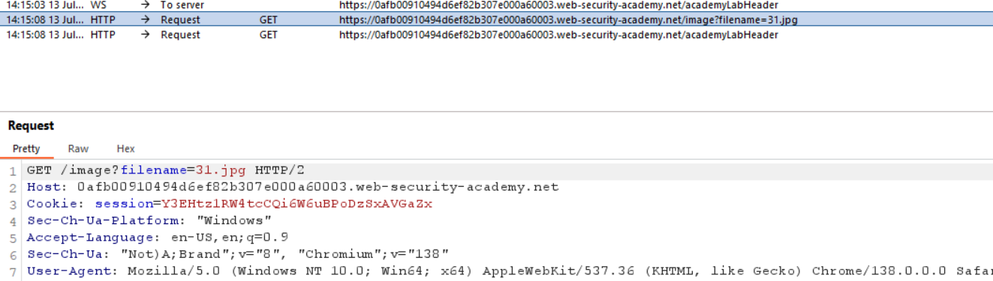

- In the filename field, we will replace it with another injection, asking the system to return the image, and send the command that we previously injected. To perform it, we will replace the filename content for output.txt. Click on the Forward All button.
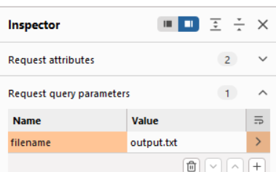
- To check the content of the output.txt file, in the Proxy tab, open the HTTP History. Find our GET request.

- Right-click on the Original Request Button and select the Edited Request.
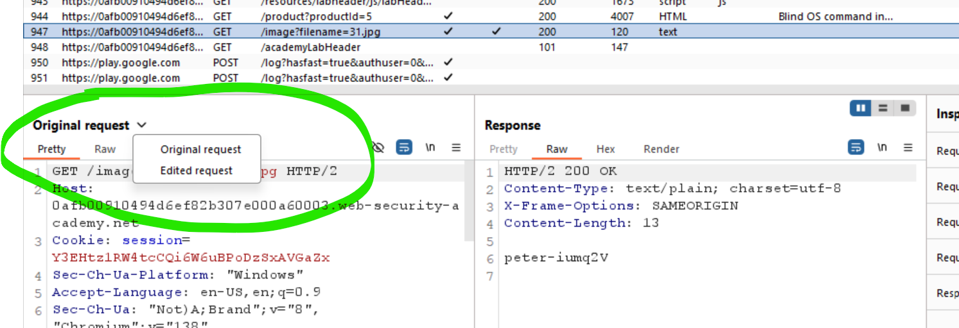

- In the response tab, you will see the response of the first injection.
